Project 1-Awesome Snakes & Turtles Game

**Test Values For MultiChoice()**

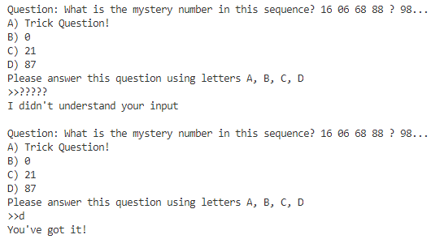

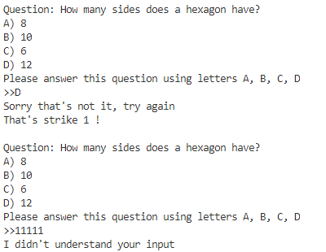

Non-alpha numeric values, correct values, incorrect values

**Test Values For RPS()**

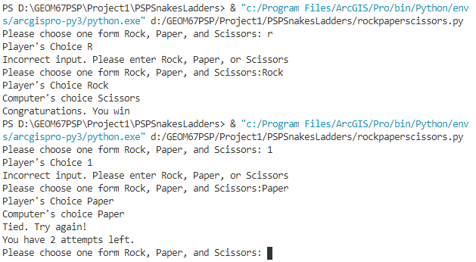

Test values included string, text, and failure conditions.

**Test Values For DiceRoll()**

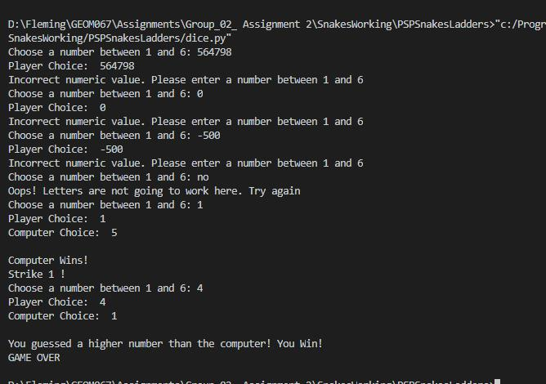

Extreme values and game ending conditions are tested.

**Test Values For Coinflip()**

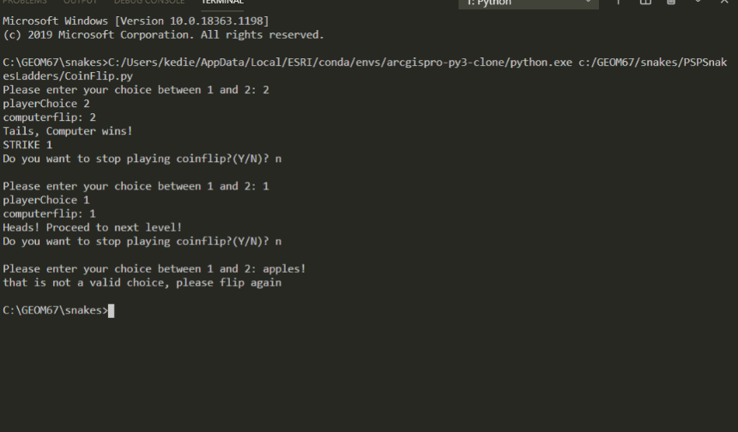

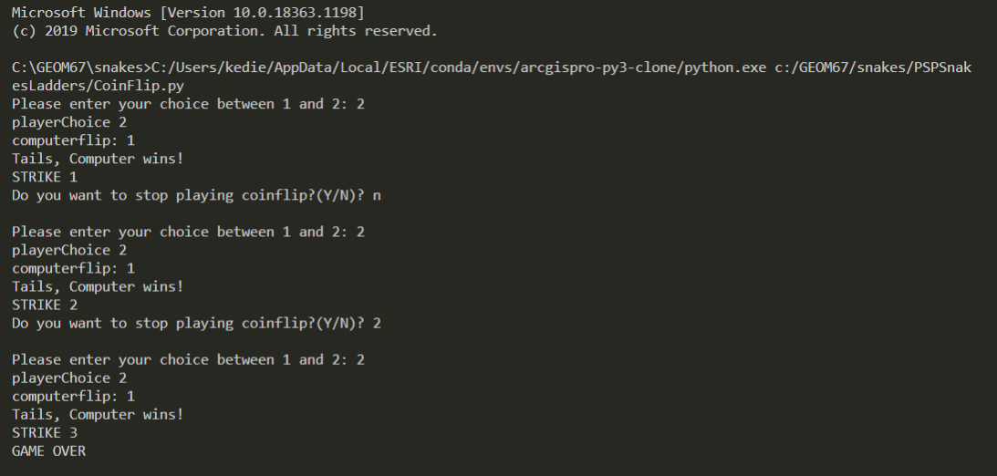Possible choices and extreme values were used (1,2, apples). Program handles non-int values and handles failure in game.

**Test Values For Replay()**

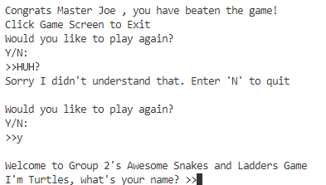

Non alphanumeric values, lower case values